Design Rational

**Summary**

My project is in conjunction with the George Mason University Plaster Cast Project. As part of this 10-year project we have decided to digitize our catalog of plaster casts. We have several goals that we hope to achieve with this website. The first and most important is to make the site searchable for other researchers who are studying plaster casts. To that end we have decided that a simple site, which is easy to navigate and also easy on the eyes would be most beneficial. We have chosen a simple color pallet, which is evocative not only of the Mediterranean, which most of the original pieces hail from, but also uses, muted tones of George Mason’s school colors.

**Logo**

For the logo we have chosen an altered version of one of the largest pieces in the collection; the Ludovici Juno.

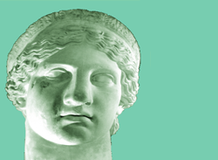

**Logotype**

In keeping with the Mediterranean theme, we have chosen Herculanum for the headings and Bangala Sangam NM for the body of the text. We have chosen Bangala Sangam NM specifically because it is easy to read and does not strain the eyes because this is an online catalog there is a lot of text for each entry. We wanted to make sure that the text was clear and legible. We are aware that they are Apple specific fonts and are currently searching for other fonts that are more universal. Currently we haven’t found any.

Bengala Sangam NM

Herculanum

**Color Palette**



**Hex #: e4e48a Hex #: 77cdb0 Hex #: 99ccff**

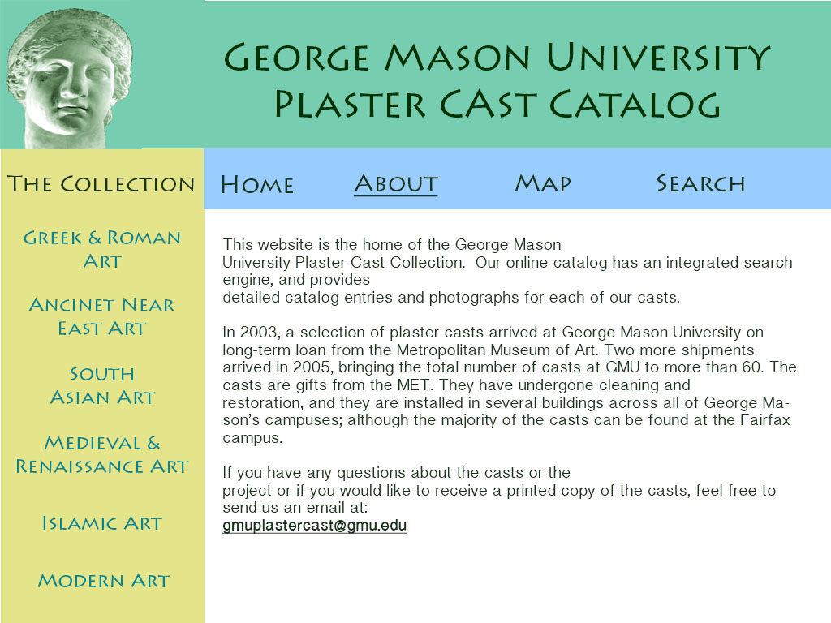**About Page**

**Sample Catalog Page**

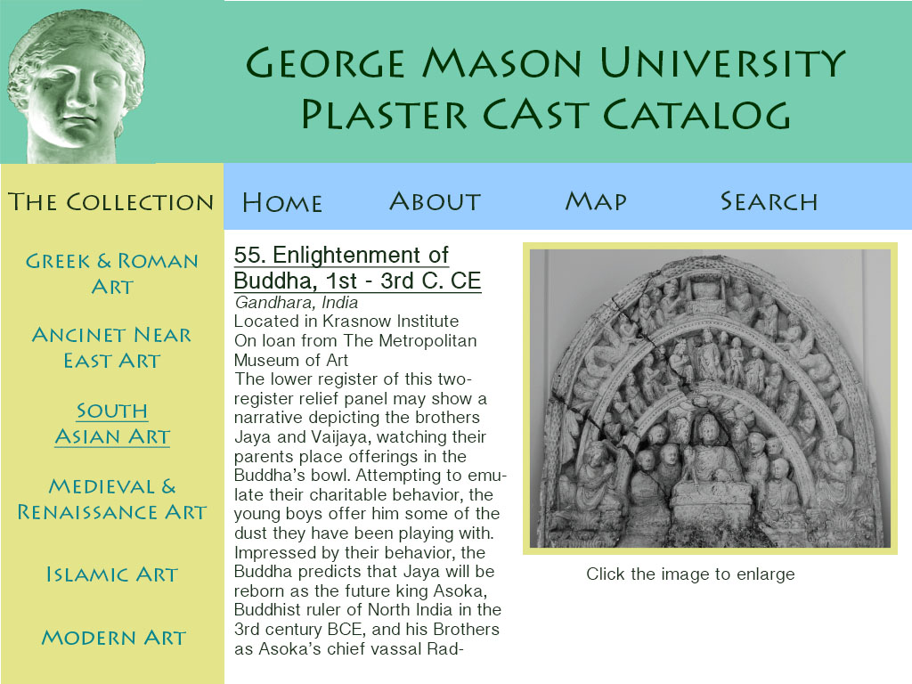

**Sample Thumbnail Page**

